***EE252 EMPEL***

**Buck Boost Converter**

E1 B7

horizontal line

# 

# Introduction

A buck-boost converter is a type of DC-DC converter that can step up (boost) or step down (buck) an input voltage to maintain a desired output voltage. It is widely used in applications where the input voltage may vary above or below the output voltage, such as battery-powered systems. This project aimed to design, simulate, and fabricate a buck-boost converter to understand its working principles and evaluate its real-world performance.

The PCB for the converter was designed using EasyEDA software. Fabrication of the PCB was carried out at the Makerspace Lab, IIT Indore. To validate the theoretical and experimental results, simulations were performed using MATLAB Simulink, incorporating non-idealities for a more accurate comparison.

## Components used:-

* Power mosfet IRFZ44NPbF
* Power diode QH08TZ600
* PWM IC TL494
* Mosfet driver TC4428
* Inductor 2324-RC
* 470 microfarad capacitor
* Rheostat as load
* DC power supply

### 

### MATLAB SIMULINK MODEL

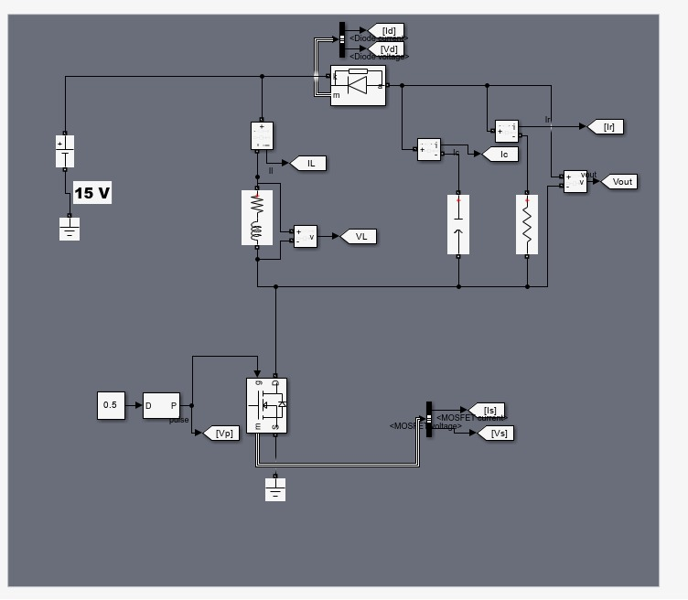

**Non idealities considered:-**

Inductor ESR=0.4 ohms

Average diode forward voltage drop = 1.75 V

Mosfet Rdson = 0.022 ohms

Simulation waveforms for Rload=16 ohms, D=0.5 , Vin=15 V

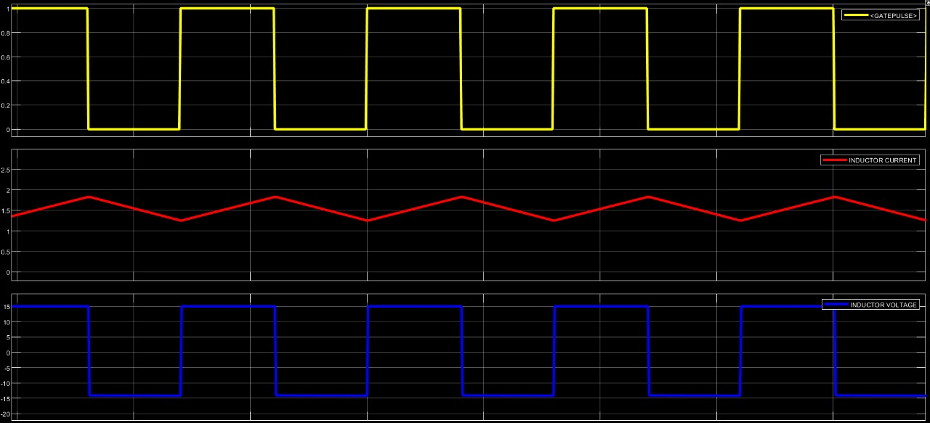

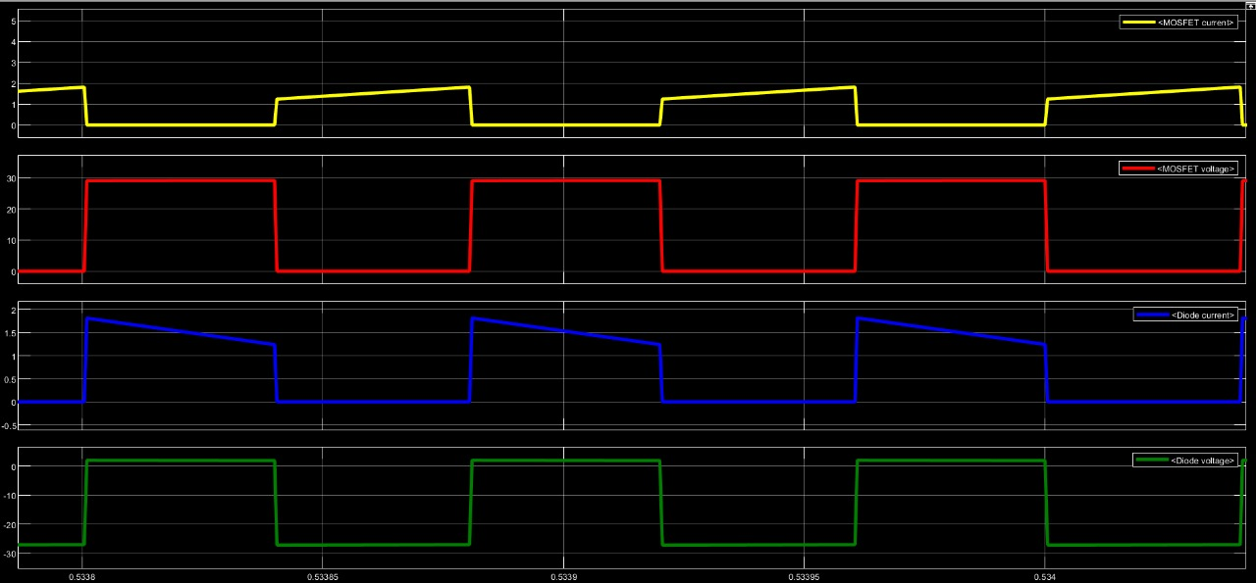

**PCB SCHEMATIC**

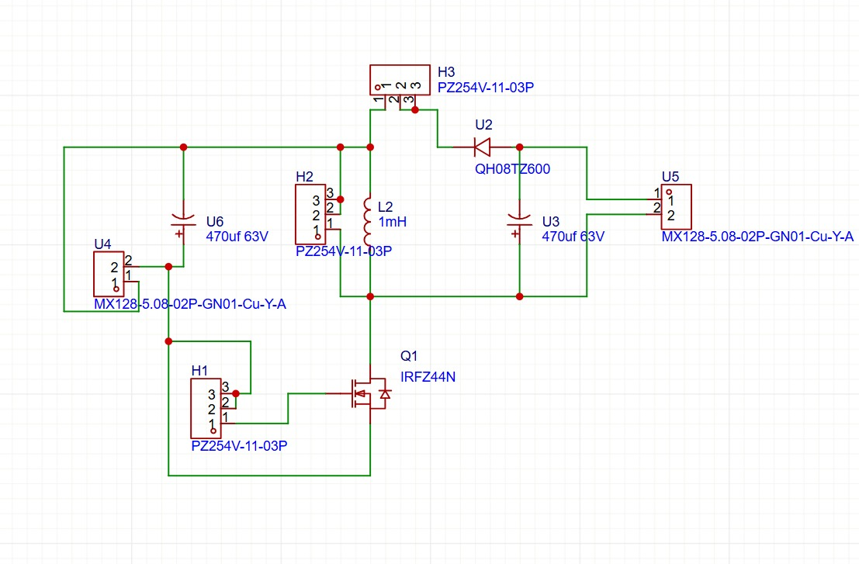

We have used berg pins to get connections to measure inductor voltage and diode current.

**WAVEFORMS OBTAINED ON TESTING**

1. Vin = 15 V,Vout = -13 V, RLoad=16 ohms, D=0.5,f=12.5 KHz

Yellow -- Gate pulse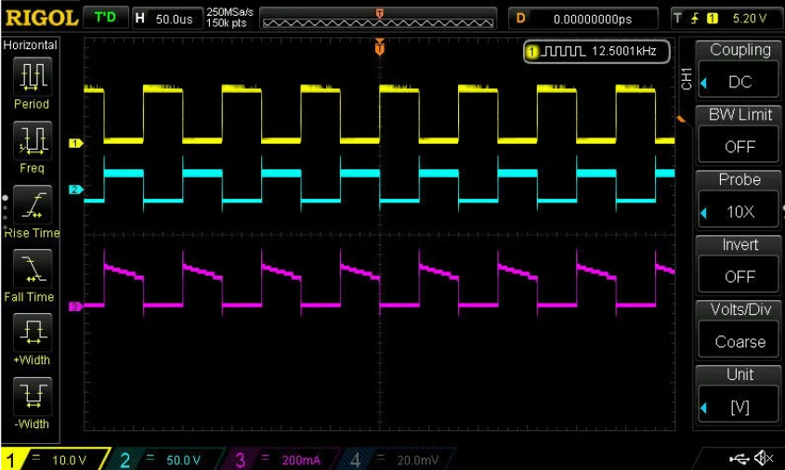

Blue -- Inductor Voltage

Pink -- Diode current

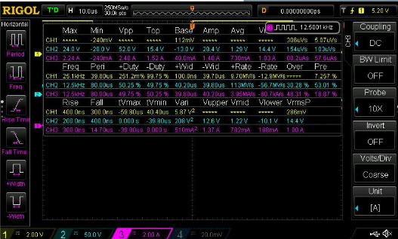

Measurements:

Inductor voltage varies between 15 V to -13 V i.e between Vg and Vo

Diode current average is 736 mA

**Results match with simulation results!**

1. Vin = 15 V,Vout = -15.7 V, RLoad=27.8 ohms, D=0.55,f=12.5 KHz

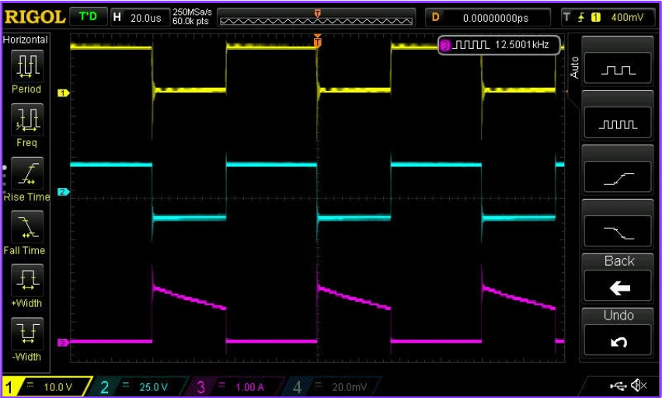

Yellow -- Gate pulse

Blue -- Inductor Voltage

Pink -- Diode current

Measurements: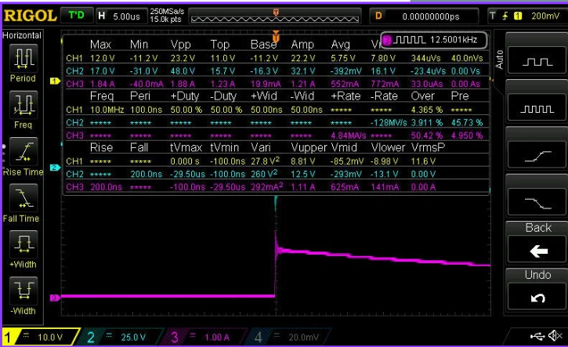

Inductor voltage varies between 15.7 V to -16.3 V i.e approximately between Vg and Vo

Diode current average is 552 mA

1. Vin = 15 V,Vout = -19.6 V, RLoad= 28.9 ohms, D=0.6,f=12.5 KHz

Yellow -- Gate pulse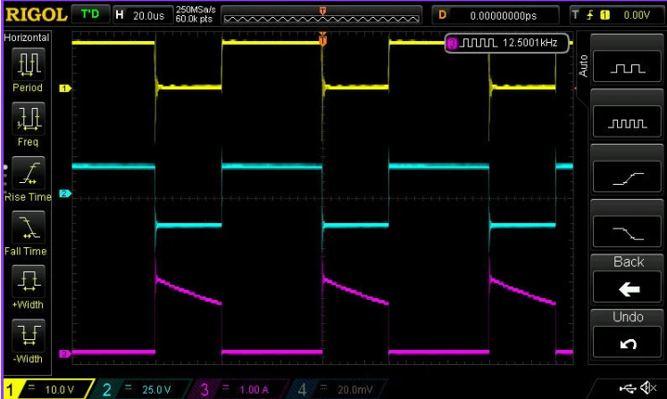

Blue -- Inductor Voltage

Pink -- Diode current

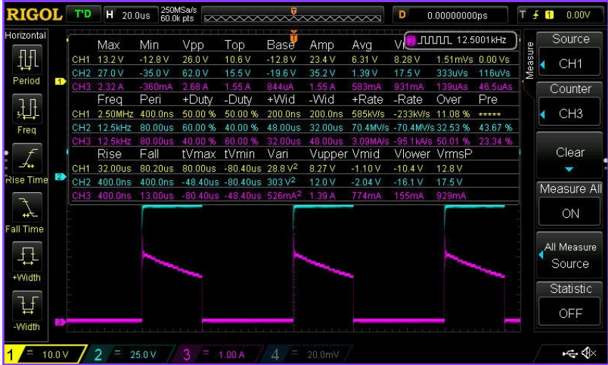

Measurement:-

Inductor voltage varies between 15.6 V to -19.6 V i.e approximately between Vg and Vo

Diode current average is 583 mA

1. BCM obtained around f=1.5 KHz

Inductor voltage goes to zero for a very short time at the end of cycle,hence bcm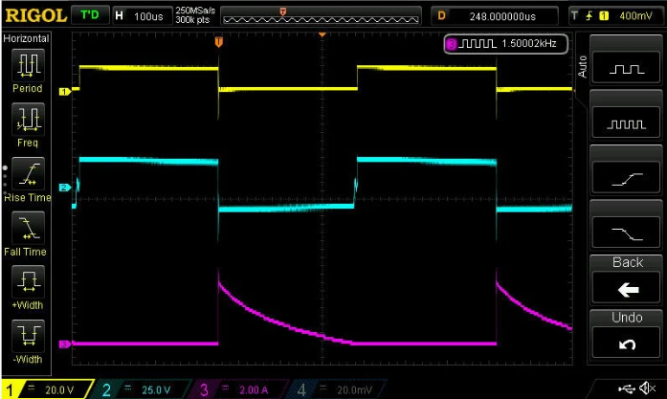

DCM ,f=1kHz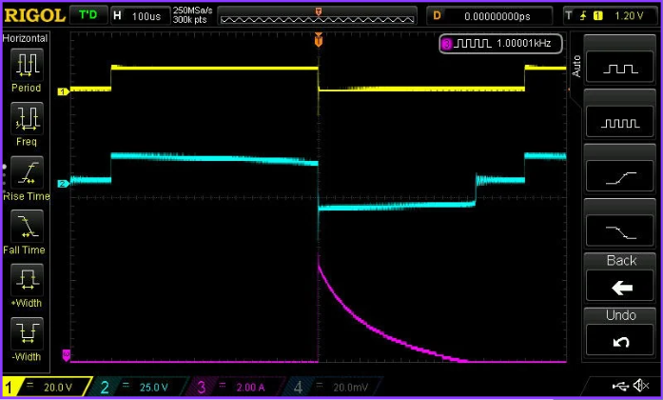

**Conclusion**

Through this project, we successfully designed, simulated, and fabricated a buck-boost converter, gaining practical insights into its operation and real-world behavior. The use of MATLAB Simulink allowed us to model the converter accurately and compare theoretical results with experimental data. Designing the PCB in EasyEDA and fabricating it at the Makerspace Lab, IIT Indore, provided valuable hands-on experience in circuit realization. Overall, the project deepened our understanding of power electronics and highlighted the importance of bridging simulation with practical implementation.

**Precautions and possible reasons for failure**:

* Check the circuit carefully before giving any input.
* Set the attenuation of differential probe and current probe accordingly.
* Don't connect the MOSFET directly without pasting it to heatsink else it may get burnt out or/and damage the circuit.